**Jira Project Tracking Summary**

**Project:** College Management Portal  
**Tool Used:** Jira (Team-Managed Project)  
**Methodology:** Agile Scrum

• **Project Setup:**

* Created a **Scrum-based Team Project** in Jira named College Management Portal (CMP).

• **Epics Created:**

* Student Management Module
* Faculty Management Module
* Exam & Results Module
* Fee Management Module

• **User Stories Added:**

* Defined user stories under each Epic.
* Examples: "Register new student", "Add faculty profile", "Enter exam marks", etc.

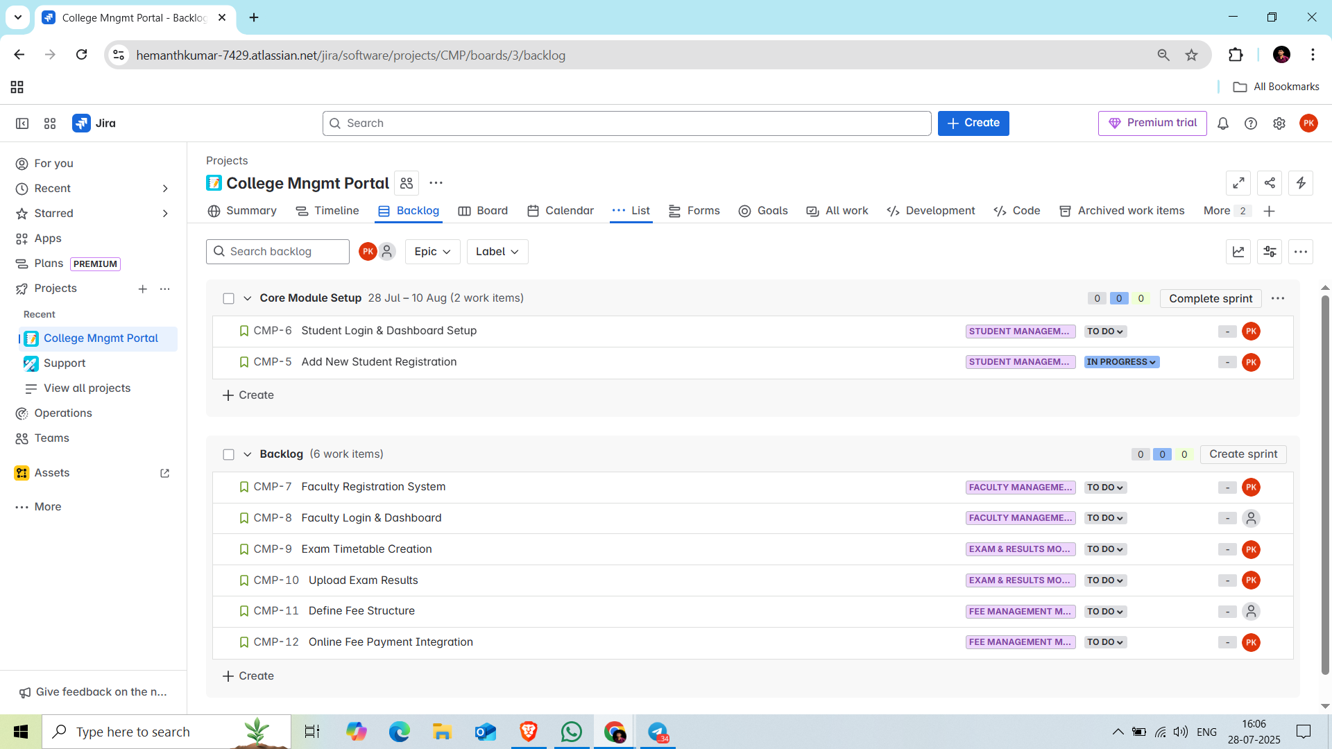

• **Sprint Planning & Execution:**

* Created **Sprint-1**, added relevant stories.
* Defined start/end dates and started the sprint.

• **Task Tracking:**

* Moved tasks through **To Do → In Progress → Done**.
* Used **Scrum Board** to visualize real-time progress.

